Assignment 8
(Exercise on order by and group by clauses) Create Sales table with the following fields ( Sales No, Salesname, Branch, Salesamount, DOB)
( a ) Insert five records
( b ) Calculate total salesamount in each branch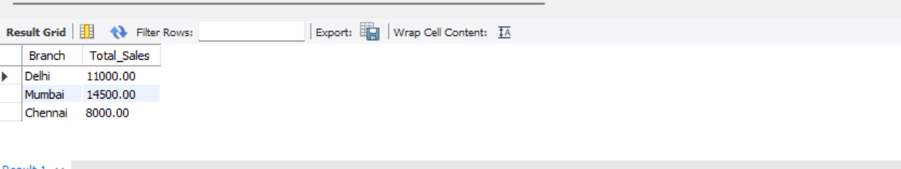

( c ) Calculate average salesamount in each branch 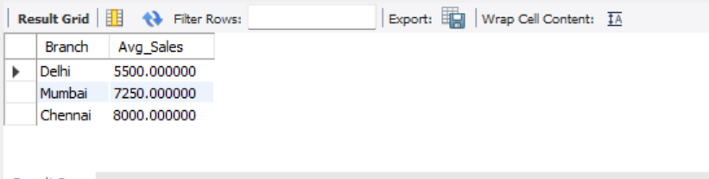

( d ) Display all the salesmen, DOB who are born in the month of December as day in character format i.e. 21-Dec-09
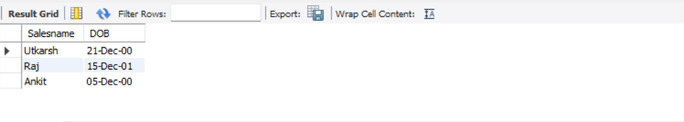

( e ) Display the name and DOB of salesman in alphabetical order of the month. 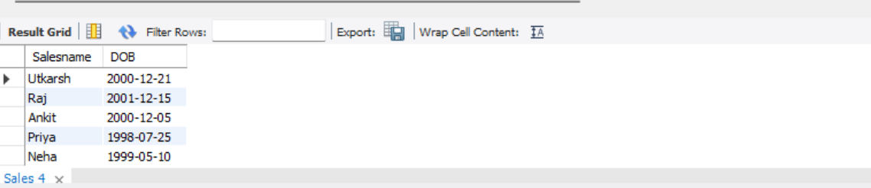

Code:
CREATE DATABASE IF NOT EXISTS experiment8;
USE experiment8;

CREATE TABLE Sales (
SalesNo INT,
Salesname VARCHAR(50),
Branch VARCHAR(50),
Salesamount DECIMAL(10,2),
DOB DATE
);

INSERT INTO Sales VALUES
(1, 'Utkarsh', 'Delhi', 5000, '2000-12-21'),
(2, 'Neha', 'Mumbai', 7000, '1999-05-10'),
(3, 'Raj', 'Delhi', 6000, '2001-12-15'),
(4, 'Priya', 'Chennai', 8000, '1998-07-25'),
(5, 'Ankit', 'Mumbai', 7500, '2000-12-05');

-- (b) Total salesamount in each branch
SELECT Branch, SUM(Salesamount) AS Total_Sales
FROM Sales
GROUP BY Branch;

-- (c) Average salesamount in each branch
SELECT Branch, AVG(Salesamount) AS Avg_Sales
FROM Sales
GROUP BY Branch;

-- (d) DOB in December in format 21-Dec-09
SELECT Salesname, DATE_FORMAT(DOB, '%d-%b-%y') AS DOB
FROM Sales
WHERE MONTH(DOB) = 12;

-- (e) Order by month alphabetically
SELECT Salesname, DOB
FROM Sales
ORDER BY MONTHNAME(DOB);

